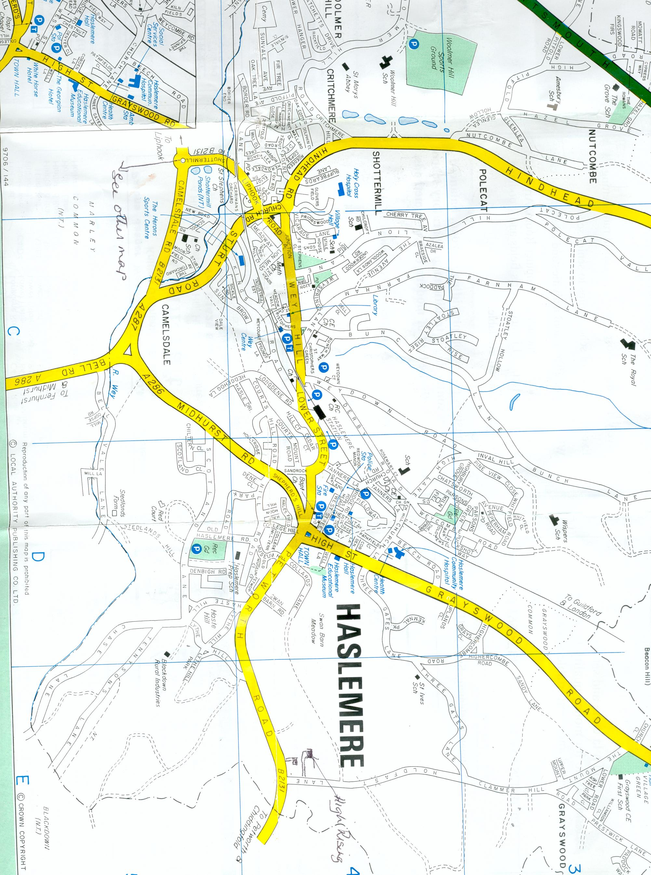
To Brook, Milford, A3 & M25
St Christopher’s Church
St Bartholomew’s Church

